**HOW TO CONVERT PPK FILE TO PEM FILE**

Download putty key generator

Open it

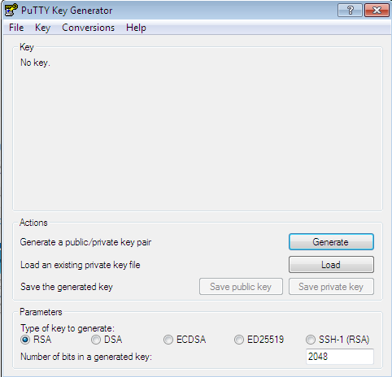

Click on load



Now open it



And select the file u want to convert in to pem file

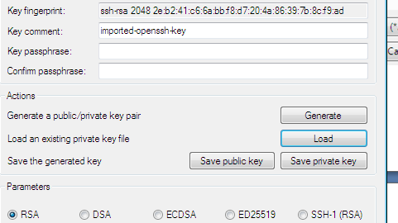

Now click on generate

And save as private key



After completing click on save as private key

After conversion file would be like this



